Assignment # 03



Spring 2024
CSE-403 Database Management Systems

Submitted by: Ali Asghar
Registration No.: 21PWCSE2059
Class Section: C

“On my honor, as student of University of Engineering and Technology, I have neither given nor received unauthorized assistance on this academic work.”

Submitted to:
Dr. Sadeeq Jan

Date:
20th May 2024

Department of Computer Systems Engineering
University of Engineering and Technology, Peshawar

Q1: Convert the ERD given below to relations. Fine anomalies and convert the relations to 2NF, and 3NF.
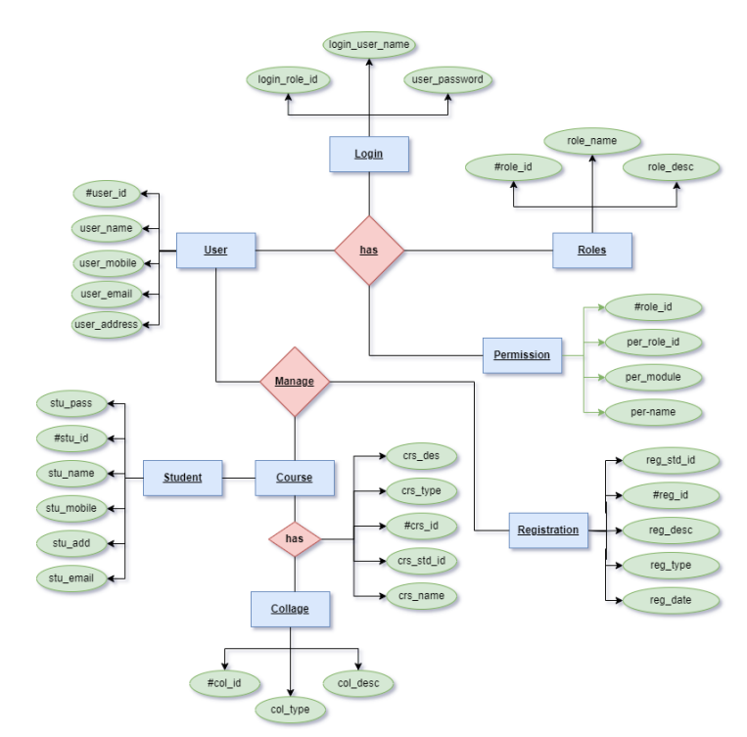

Ans:
Unnormalized Form:
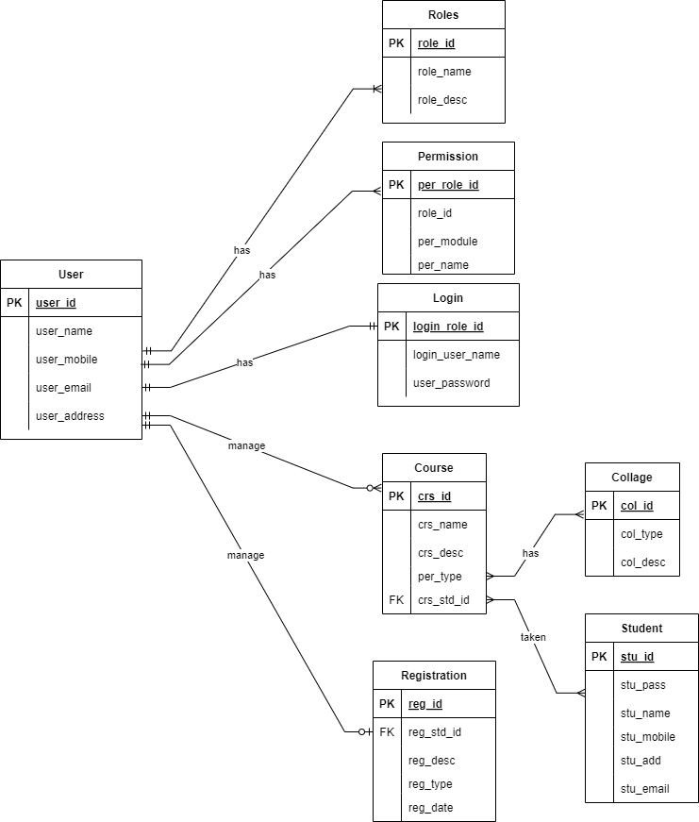

Normalized Form:
